**create table weather:**

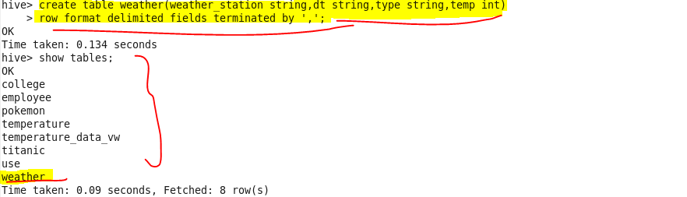

**load our dataset temperature.txt :**

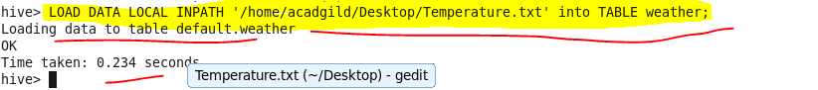

**Hive query to find the minimum temperature observed in a given weather station in a particular year:**

**Output:**

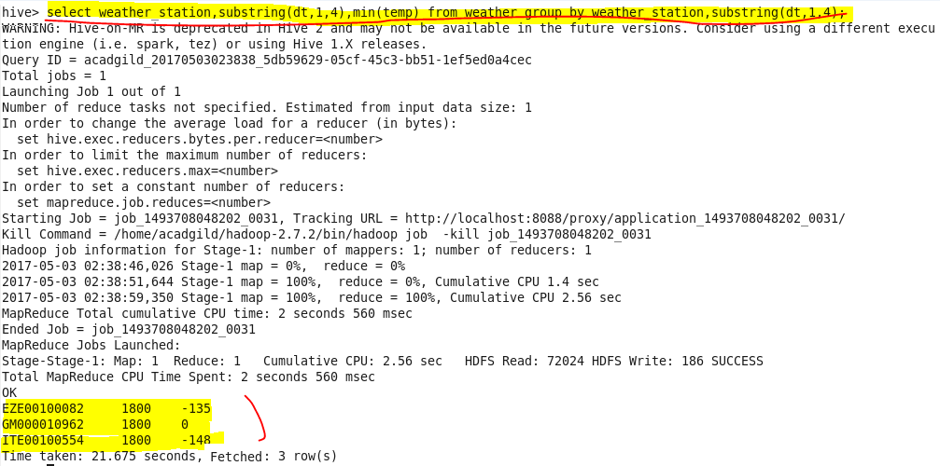

**hive query to find the maximum temperature observed in a given weather station in a particular year:**

**Output:**

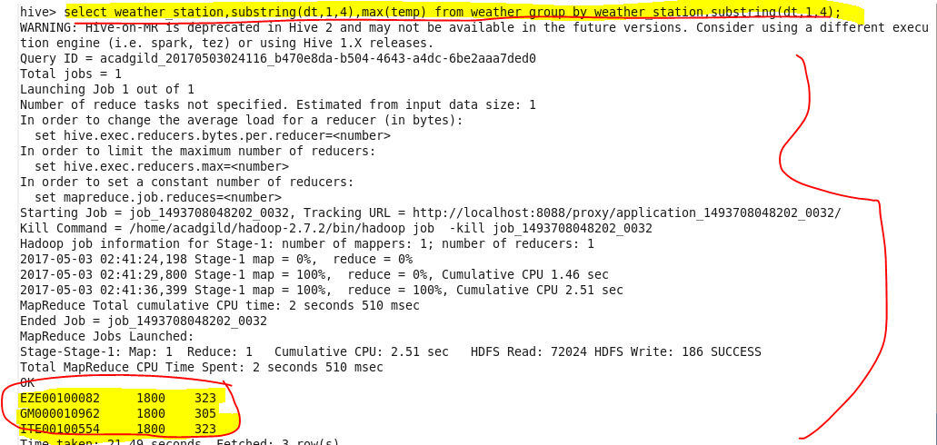

**Hive query to find the number of readings given by each weather station according to the dataset:**

**Output:**

